FurReal Friends Modification

# Summary

The FurReal Friends are a line of animatronic animals that will move and make sounds when turned on. The particular model I examined for adaptation was the orange cat model pictured below. It was fully automatic with the exception that it had to be turned on by a small switch on the bottom of the back right foot. This is where the only modifications needed to be made as the switch could not easily be turned on and off.

Image 1: FurReal Friends Orange Cat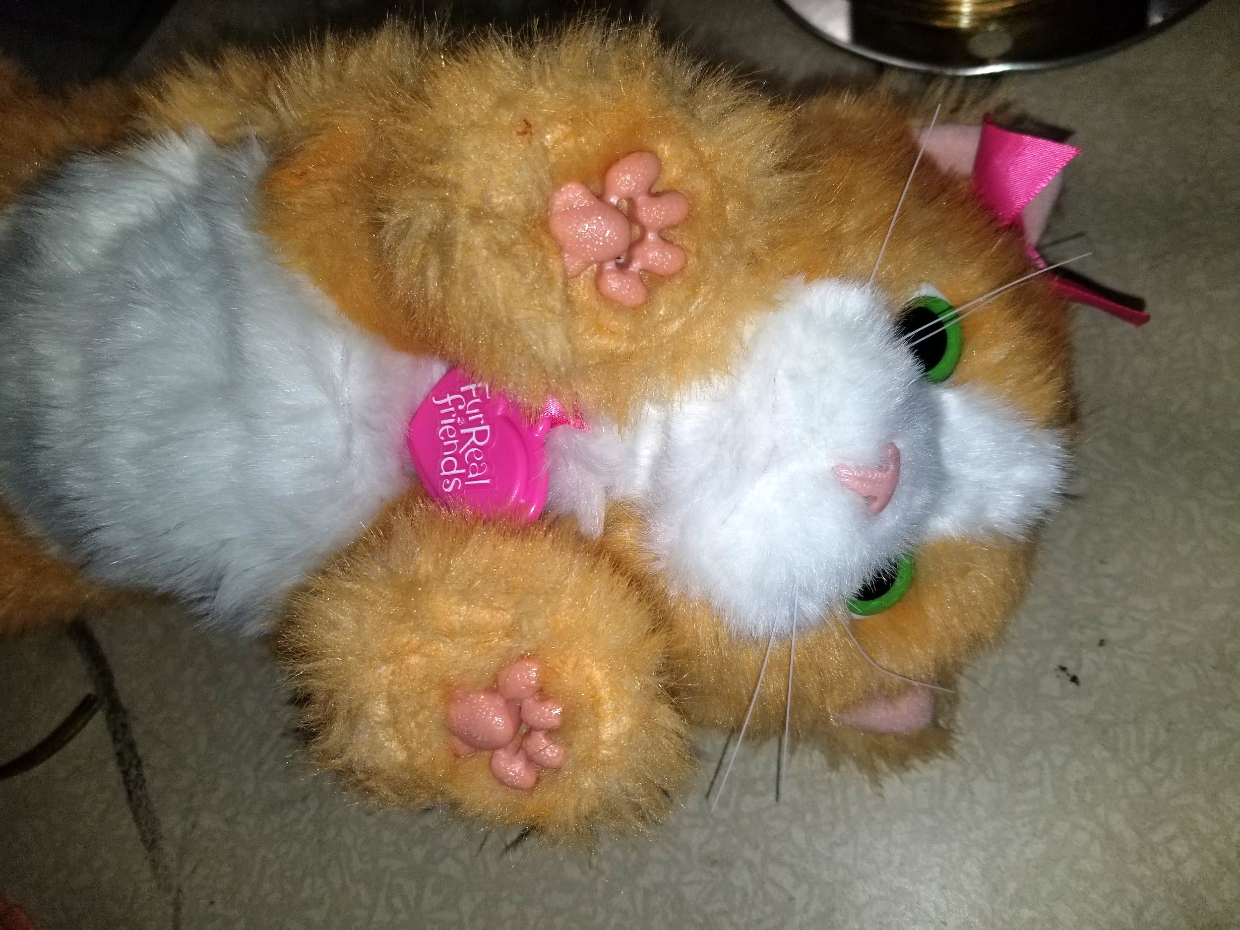

# Parts

1x Battery interrupter

1x Handicabible Button (preferably compatible with battery interrupter)

1x Solder Material (optional)

1x small wire (optional)

# 

# Modifications

The solution chosen uses a battery interrupter to block the battery signal unless a button is pressed. The battery interrupter can be slid out from the battery case beside the screw and run out to a button. This was slightly unreliable when tested.

The second solution is to solder a button between the power and the rest of the toy as well as bridge the power switch should you choose to bypass it. The first step of this solution requires removal of the fur foot covering as pictured below. This was done by peeling up at the edges of the foot covering in the front and back as well as pulling out four side clips that hook into the base foot. Once the covering is peeled up there are four screws on the top piece of the foot as well as two screws that unscrew from underneath the batteries. With the six screws removed you may separate the two halves of the foot to see the electronics

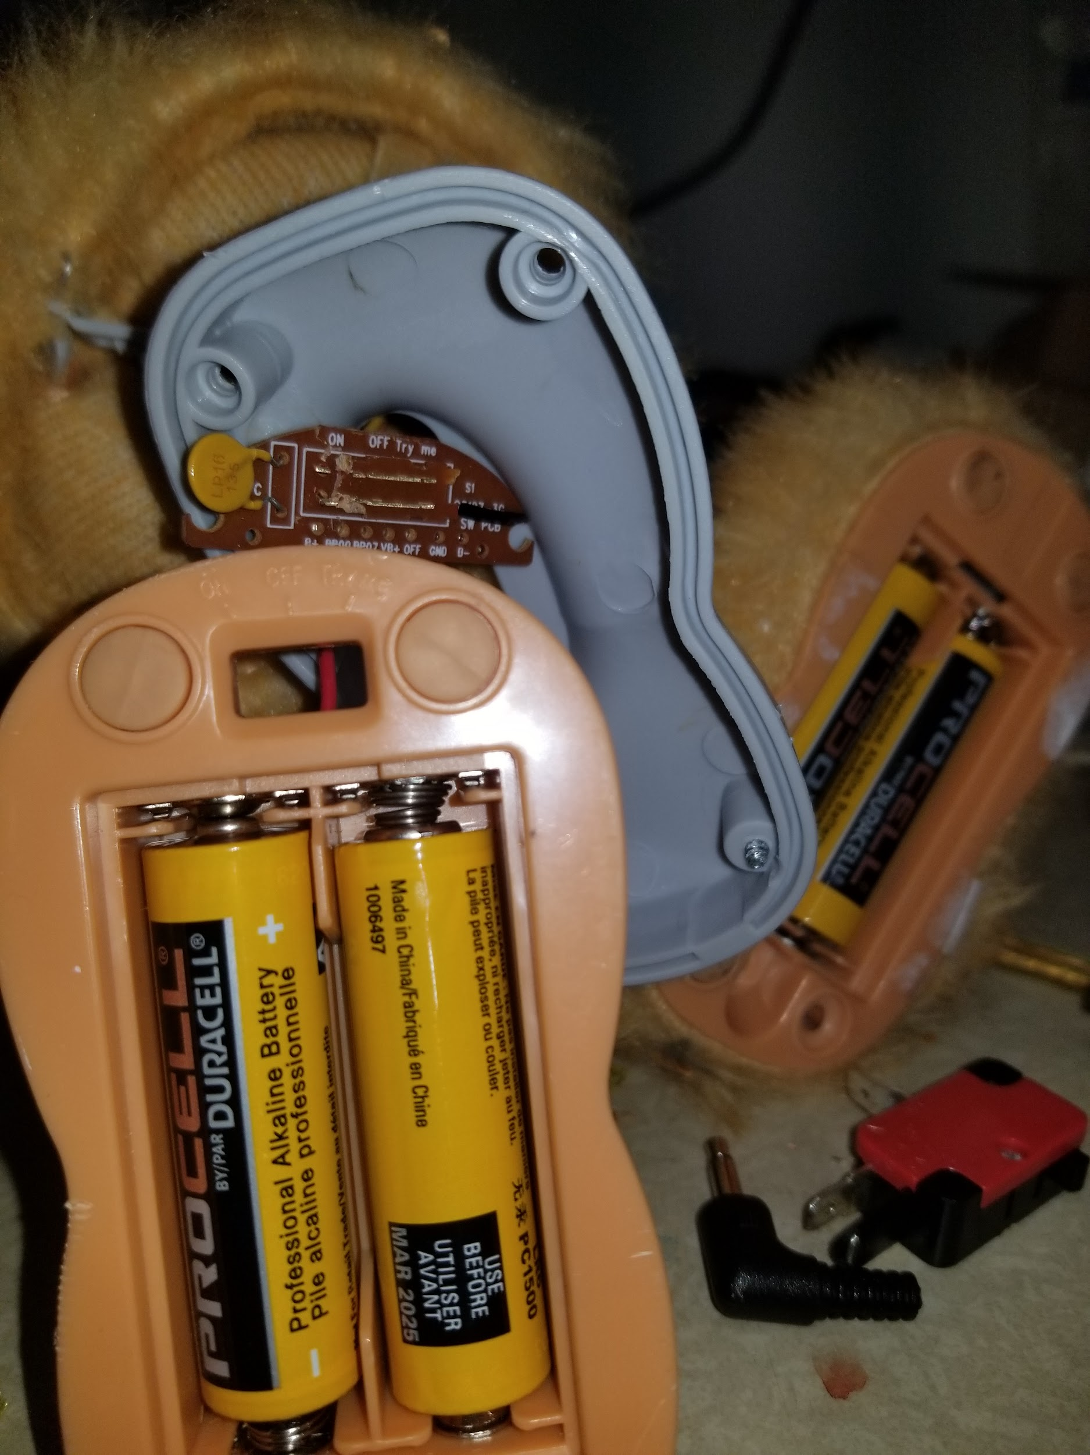

Once dismantled locate the power wire, this is where we will be splicing in our button.

Cut the power line around the center and strip the ends. Solder each end with a small strip of wire. And feed it out of the underfoot.

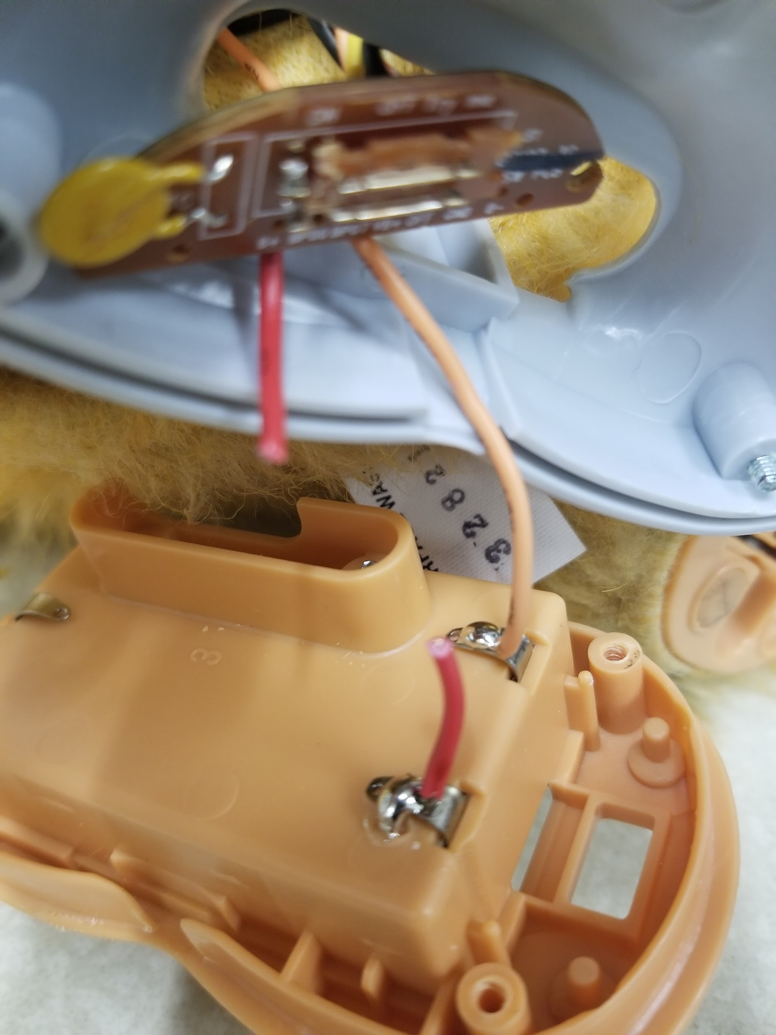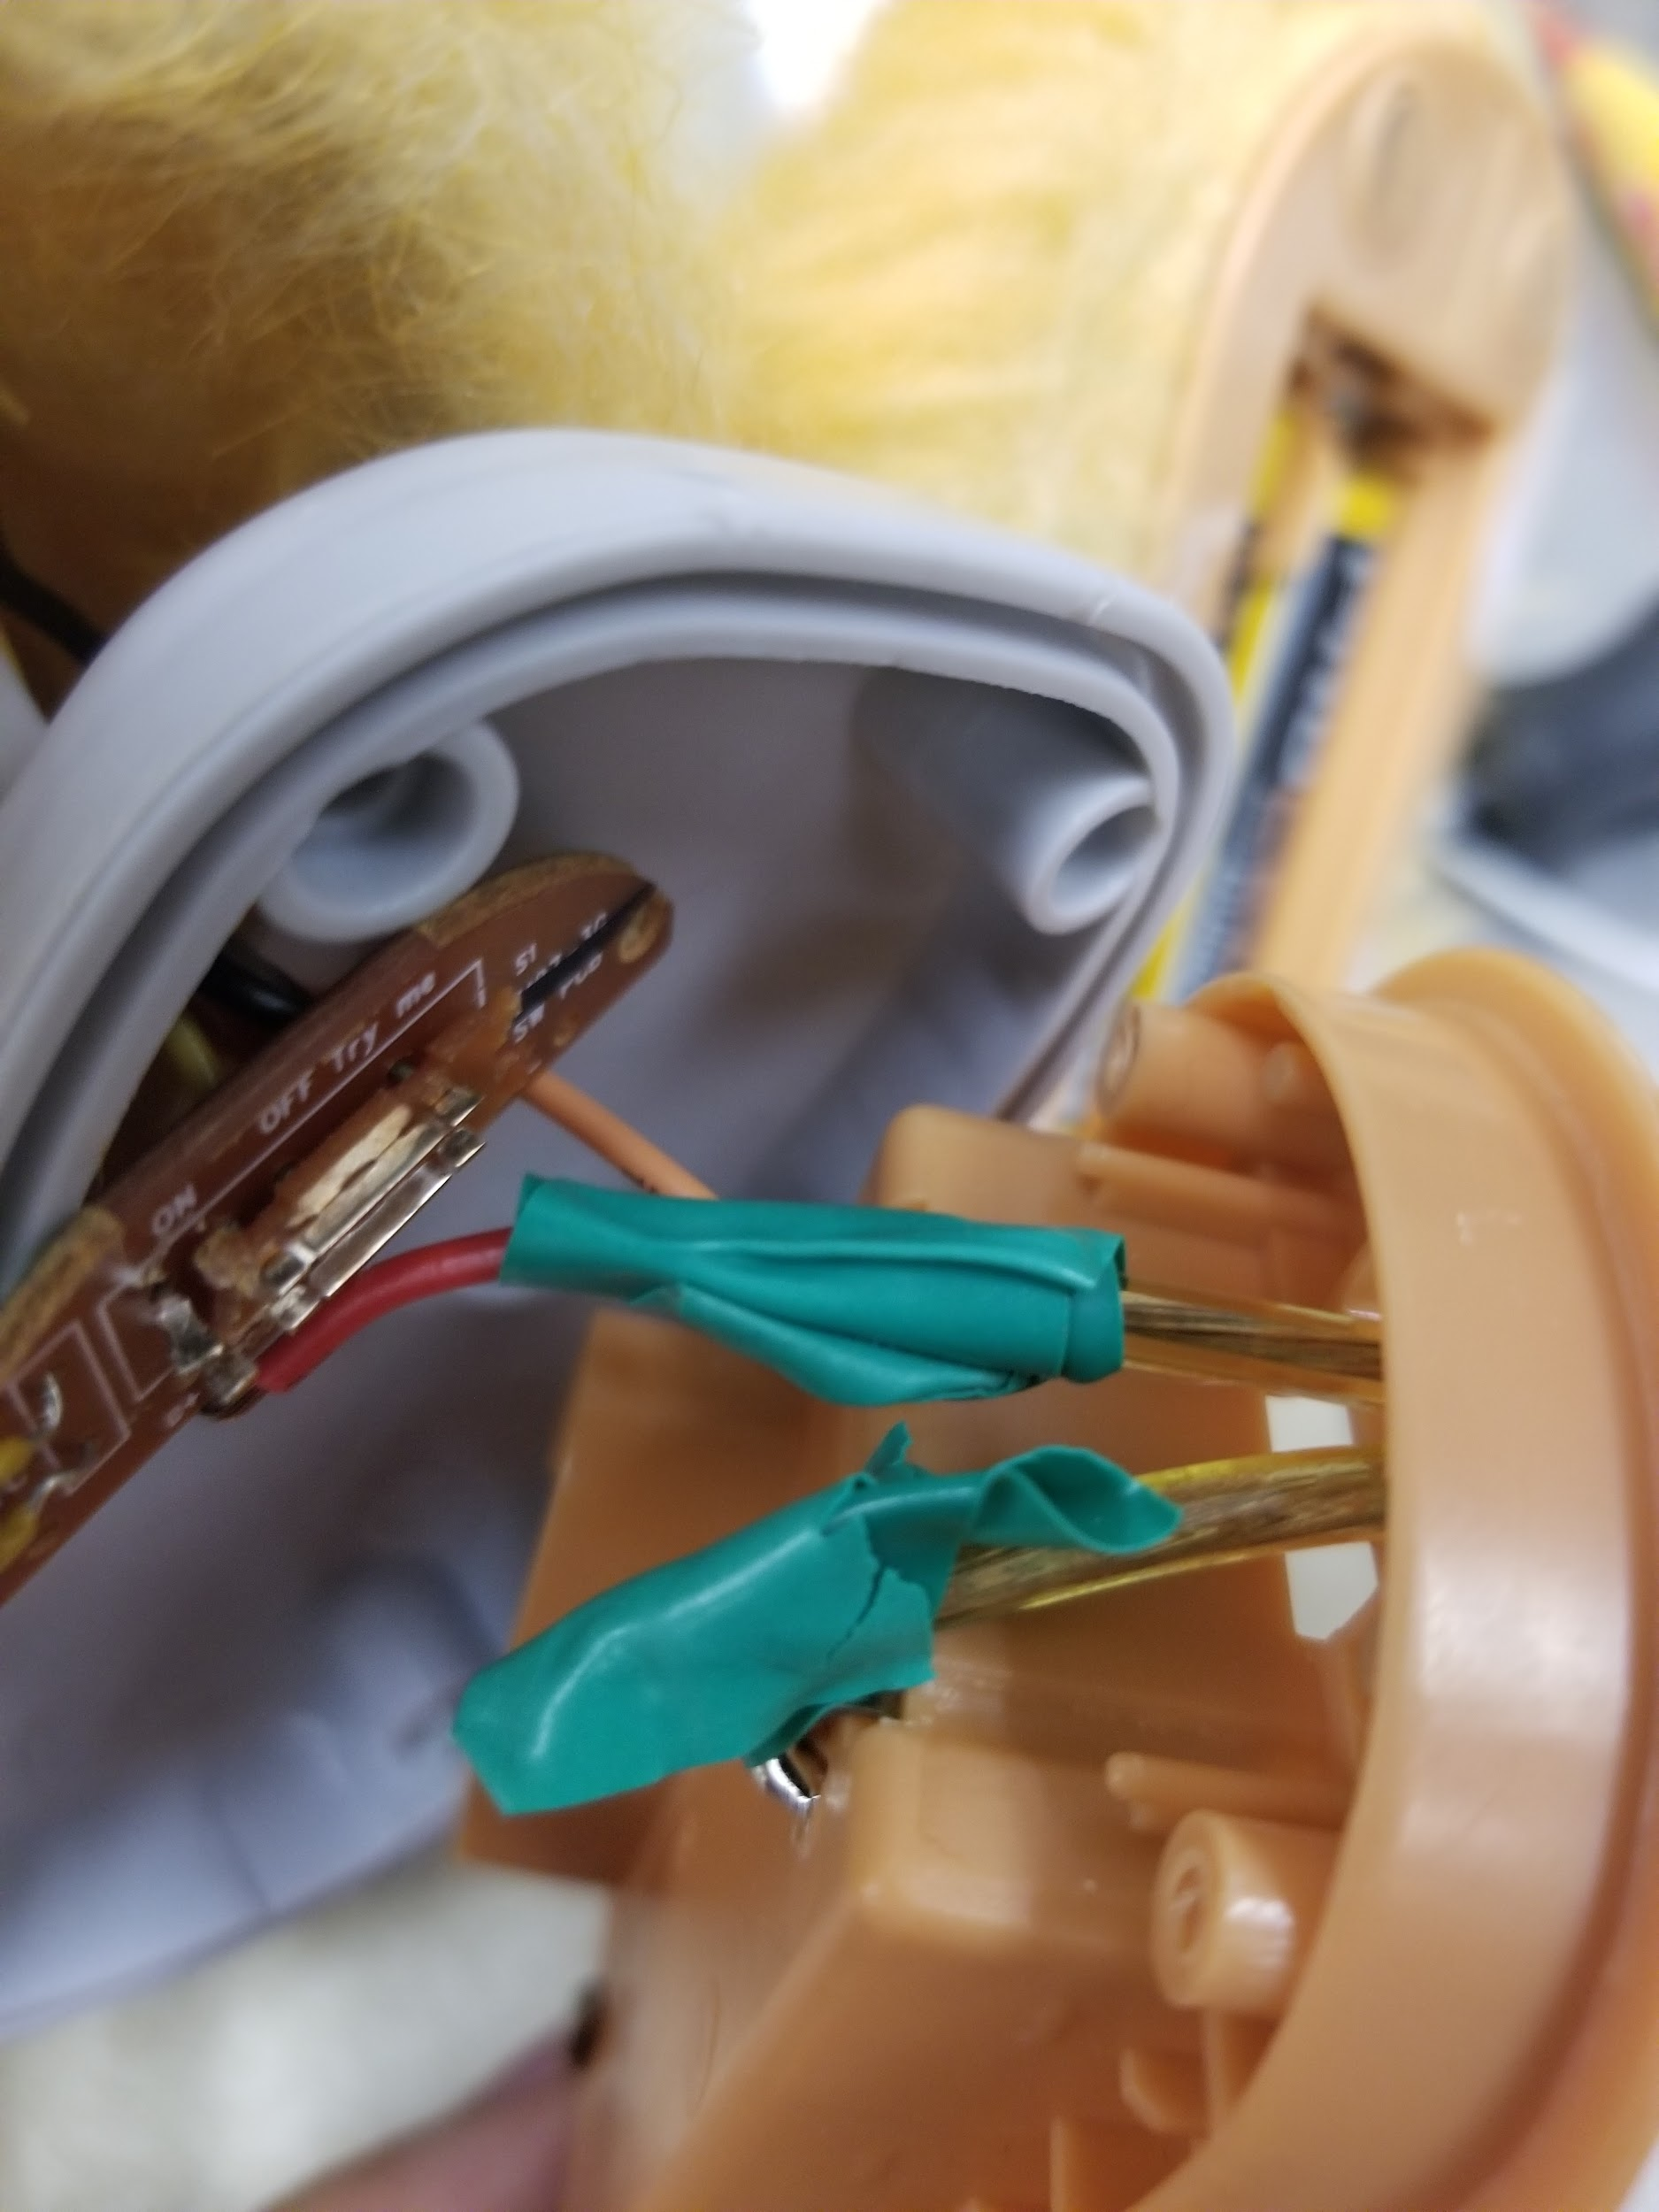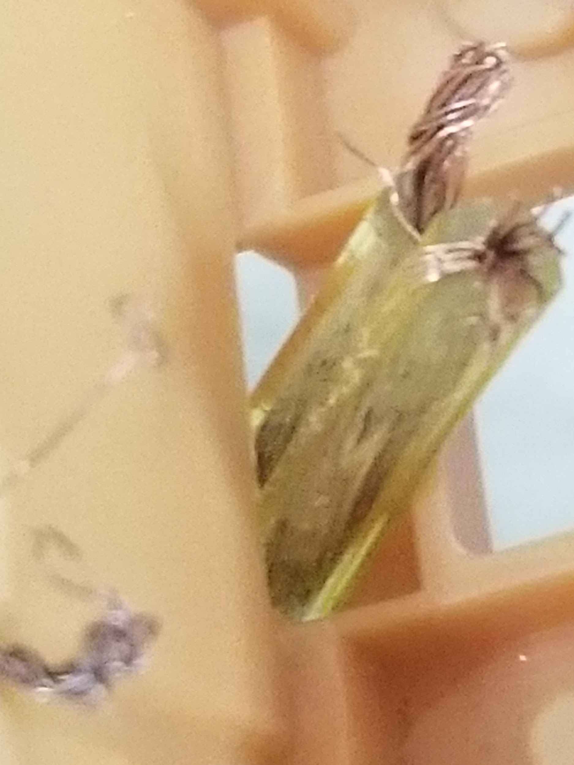

After this proceed to assemble the underfoot by lining up the parts and then screwing in the six screws. After you have secured the foot-plate find the tabs on the end of the foot cover and tuck them in each side of the foot.

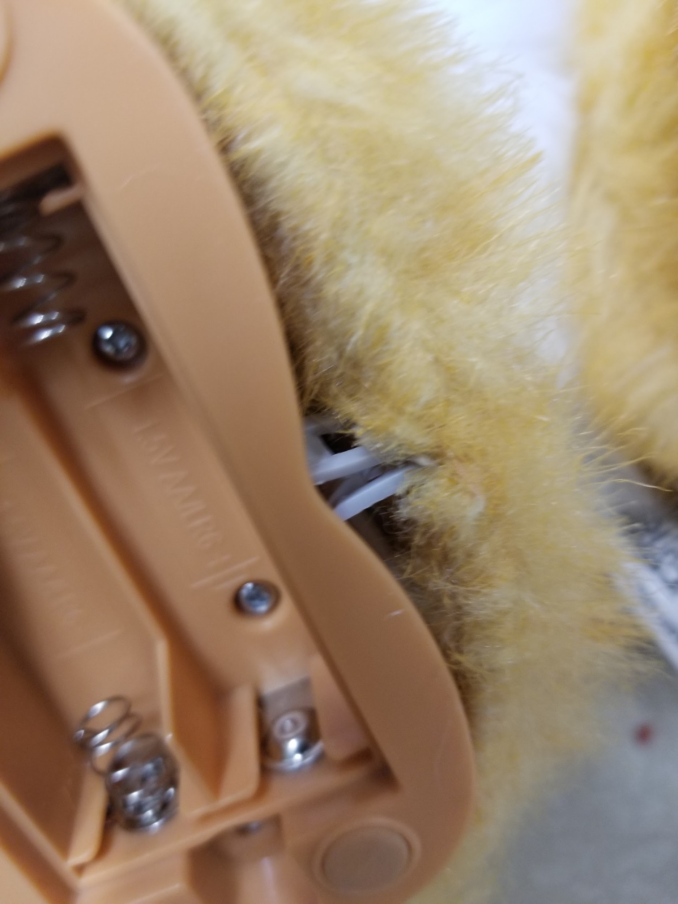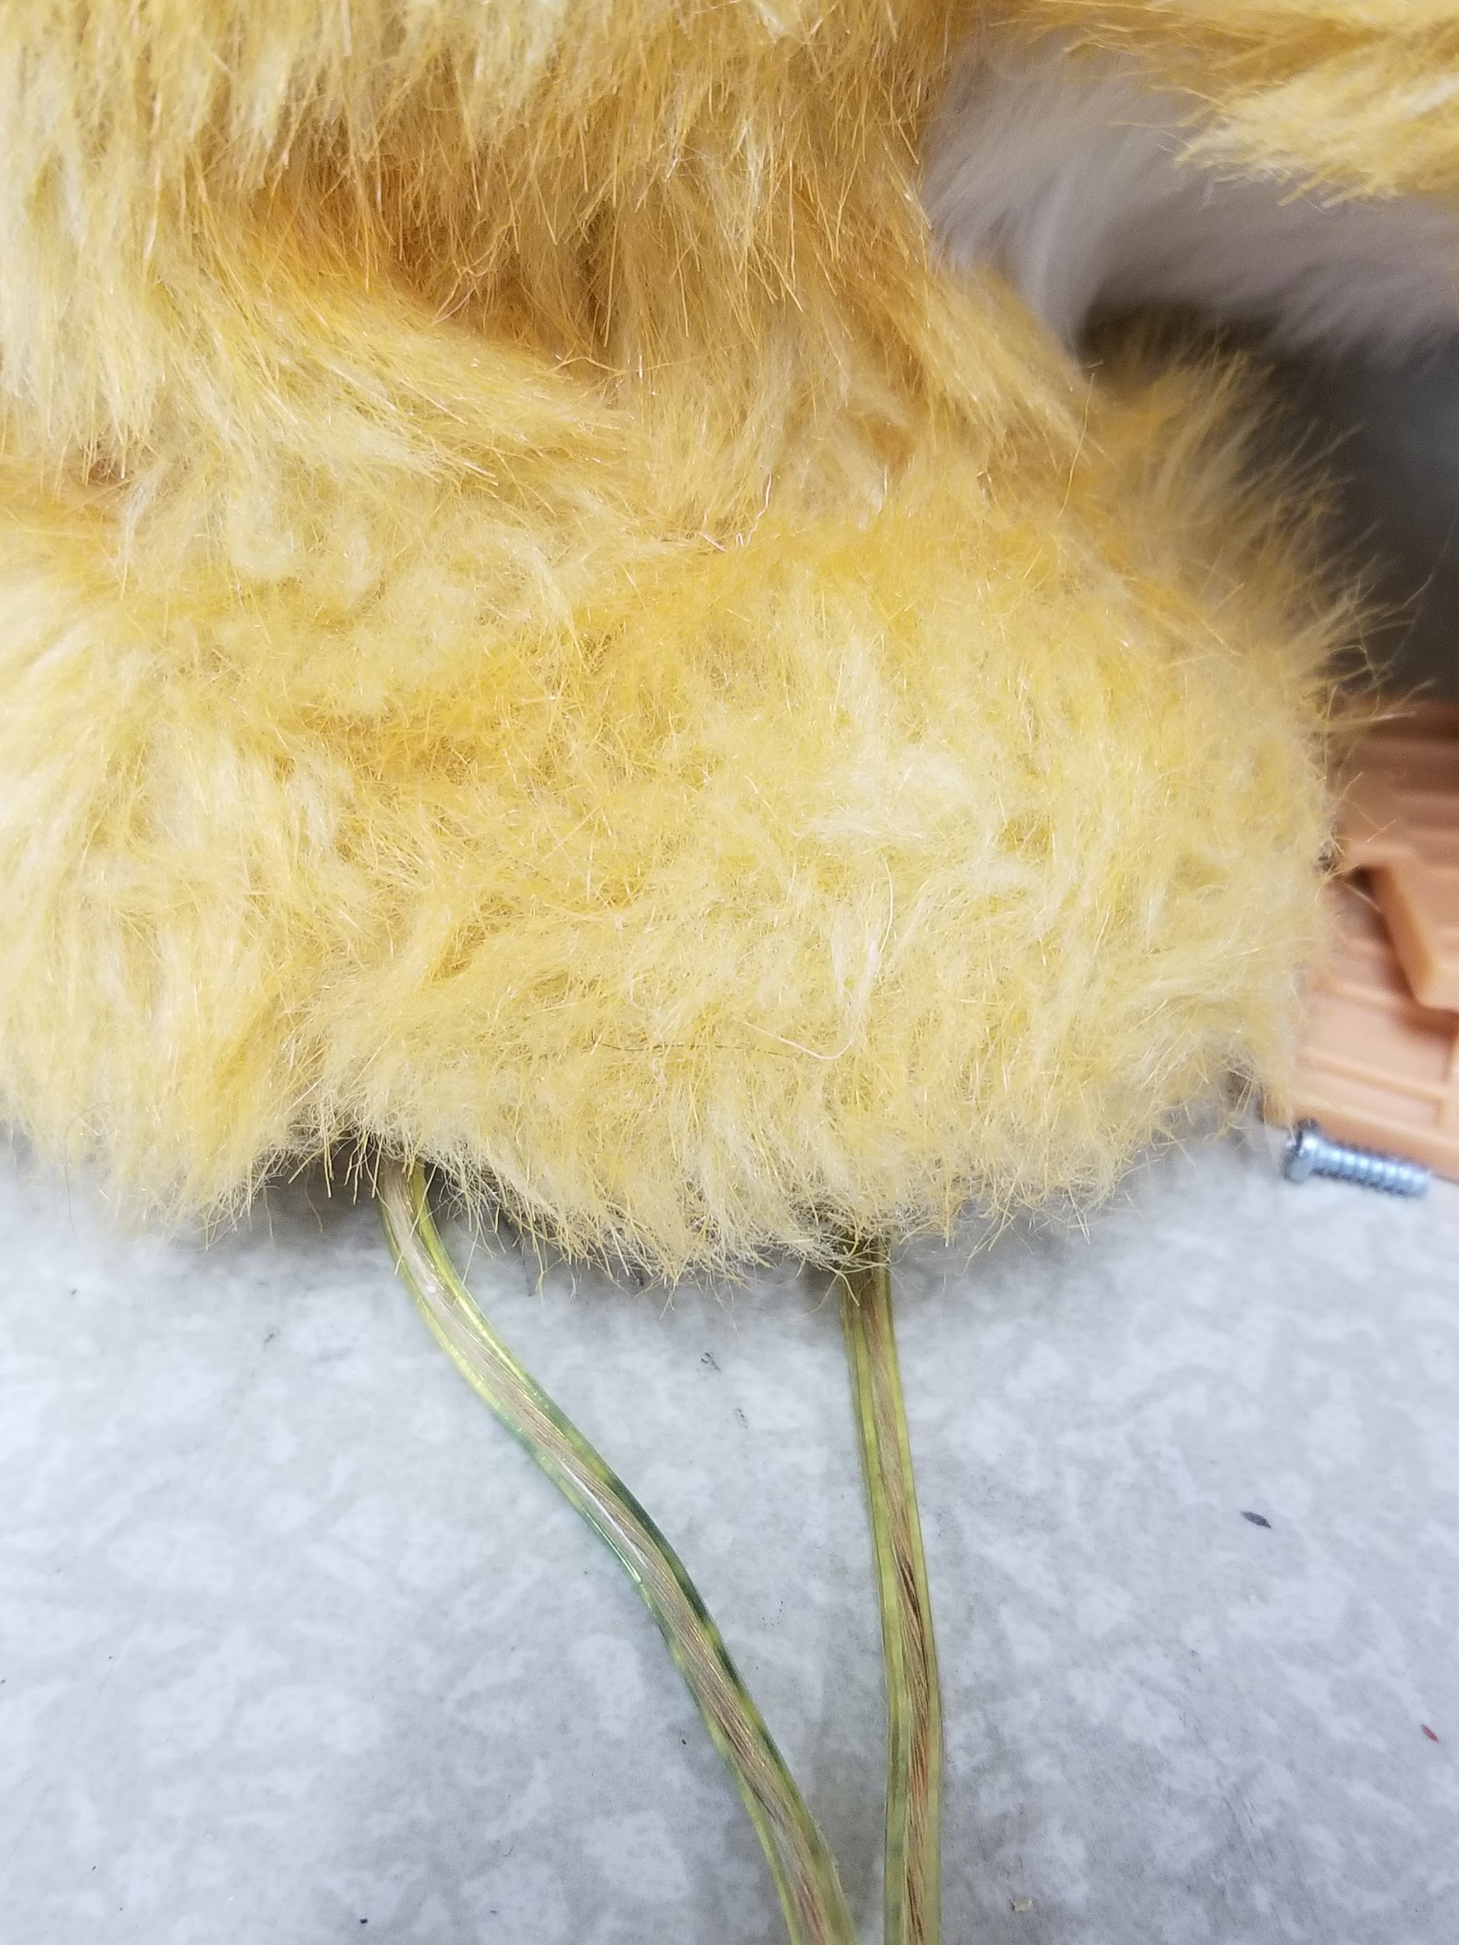

**Conclusion**

In conclusion both these modifications are fairly simple and easy to implement. A potential solution would be to use a handicapable switch instead. Finally this toy could always be used without modifications although the guardian of the child would need to switch it on and off for the child.